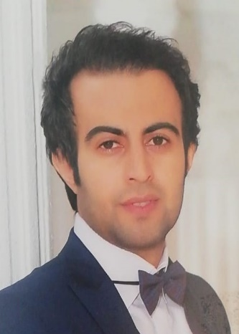
Contact
Name : Farhad Esmaeili (1988/10/01) / Full Stack .Net Developer
Email : esmaeilifarhad@outlook.com
LinkedIn : https://www.linkedin.com/in/farhad-esmaeili-50328915a
github: https://github.com/esmaeilifarhad
Phone : (98)9382537319
PROFILE
Creative web developer dedicated to developing and optimizing interactive,user-friendly,and feature-rich websites.Leverage analytical skills and strong attention to detail in order to deliver original and efficient web solutions,provide technical knowledge and expertise,build new web site from start to finish ,and successfully manage a team of web developers
Concept

- Clean / Onion Architecture
- Design Patterns
- Optimize Code
- OOP
- SOLID
- OAuth2
- Jwt
- Identity

Experience 1 :

 EGHTESAD E NOVIN BANK : SENIOR FULL-STACK DEVELOPER- 2020(JUL)-PRESENT

Banking Systems :

Maintenance and develop banking applications in various templates with the best performance including APIs, Dashboards, Web Pages, etc. These applications are generally used by organization operators or interactions between banks with each other or with the central bank. Design and develop a service provider as a core wrapper to achieve the best performance in bank card operations. Also providing Redis memory caching to most used data such as card owners or key-value paired data which need to I/O. and used the MongoDb for Log Data

Technologies : C#, .Net Core, MVC, Web APIs, WebForm ASPX, Windows Applications, Windows Services, HTML, CSS, Bootstrap, jQuery, TFS, JIRA, Restful APIs, SOAP Service

Education
University of Payamnoor (Rey, Iran Bachelor of Software(IT) 2007-2011

Experience 3 :

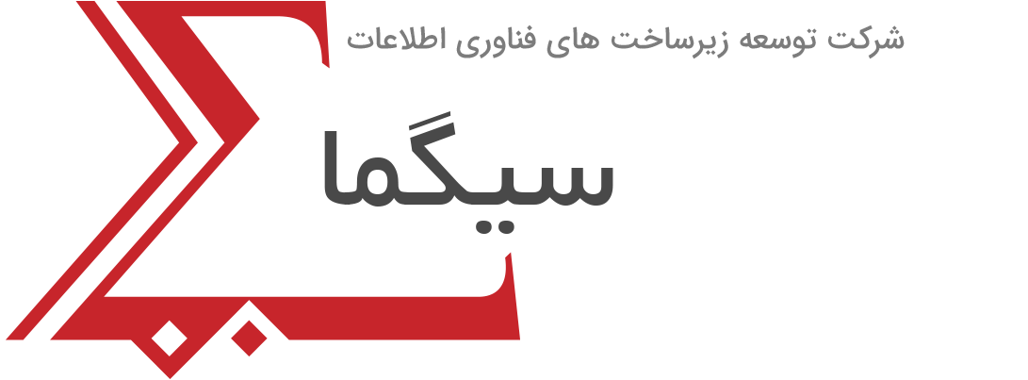 Sigma : Front End Developer 2015(JUL)-2016(MARCH)

In this company, my work was mostly related to the appearance of the site I used html css bootsatrp jquery

Experience 2 :

 Golrang Industrial Group : SENIOR FULL-STACK DEVELOPER, 2016(MARCH)-2020(JUL)
My work in Golrang Company is divided into three parts:The first part, which lasted a year, was in HR systems, payroll and clock card, where Tsql and various functions, procedures, Cursor TempTable were used for calculations, and also Asp MVC was used in EndPoint.The second part lasted two years. It was about Sharepoint, which used PowerForm, Nintext, React, and was also part of Rest Api development.

Languages
English (very good command)

SKILLS

- .Net Core / ASP.Net / C#
- Web API(Swagger/jwt)
- Signal R
…………………………………..
- Sharepoint / Nintex /Powerform
………………………...………
- Microservices, RabbitMQ
………………………..………....
- Sql Server / T-SQL / ADO .net
- Dapper
- Entity Framework / Linq
- Mongo
- Redis
…………………………………..
- React
- Html / Css
- Bootstrap
- Ecmascript
- Jquery / Java Script
………………….………………
- Agile
- Scrum
- Tfs
- GitHub

